**EX.NO-8 WEKA TOOL FOR SVM CLASSIFICATION**

DATA SET SELECTION

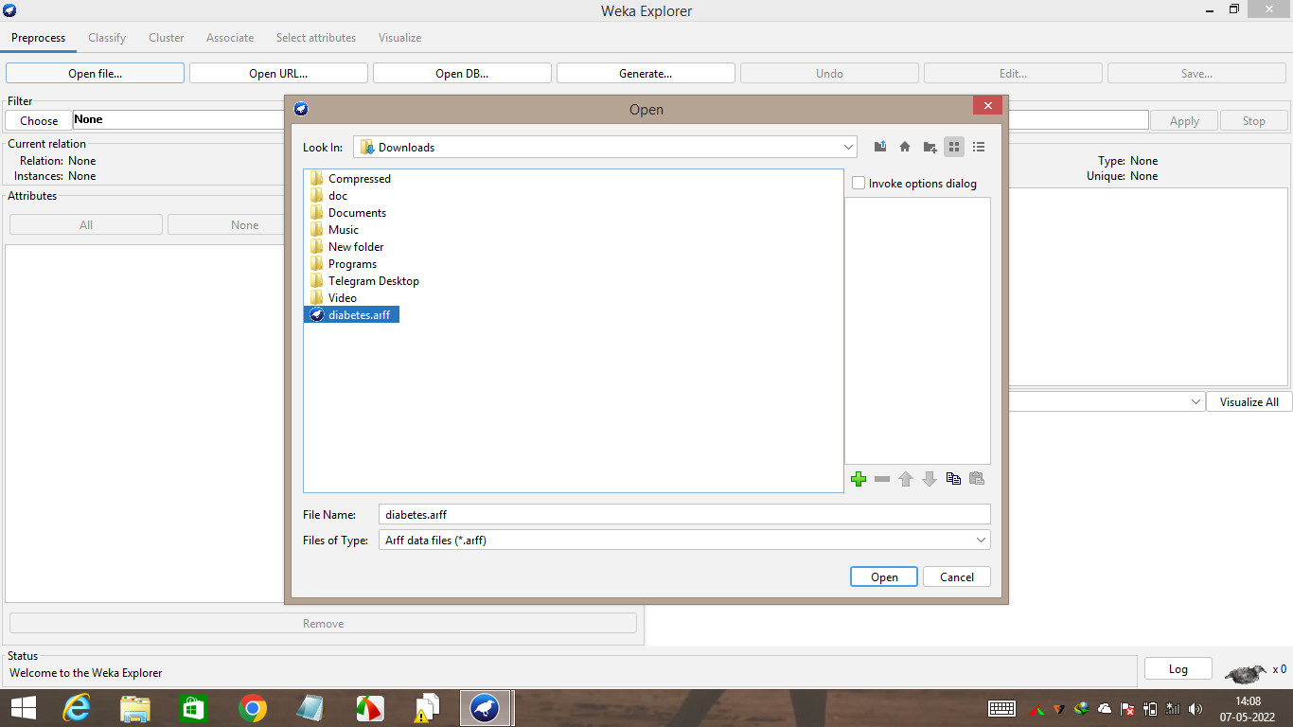

DATA PREPROCESSING AND CLASSIFICATION

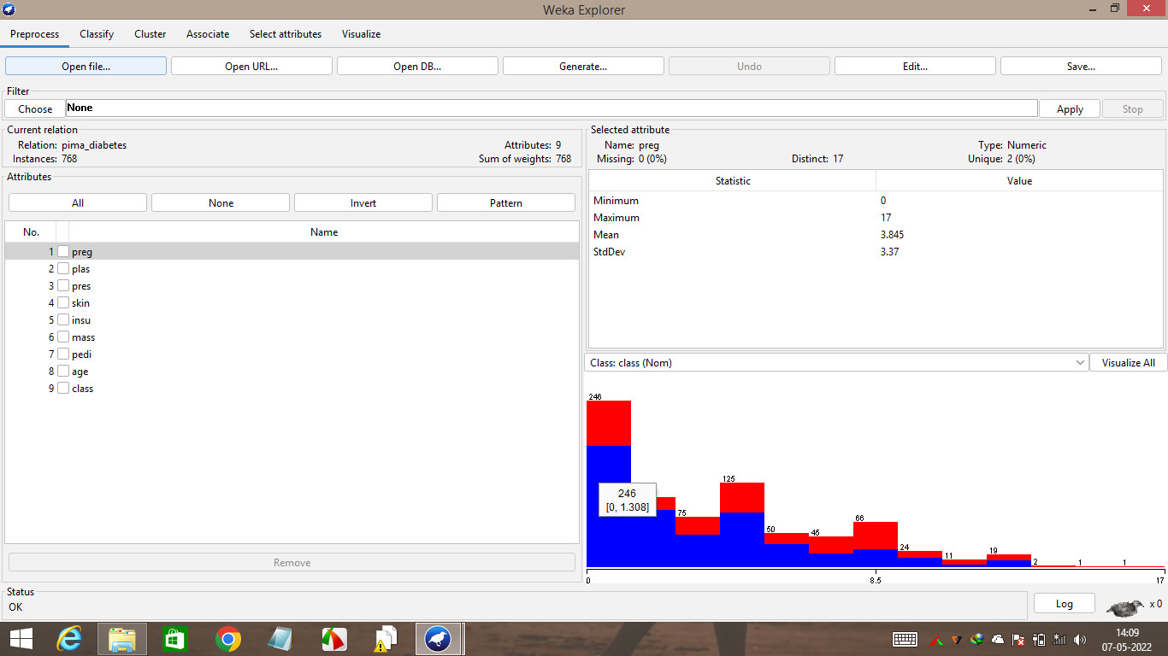

**OUTPUT**

=== Run information ===

Scheme: weka.classifiers.functions.SMO -C 1.0 -L 0.001 -P 1.0E-12 -N 0 -V -1 -W 1 -K "weka.classifiers.functions.supportVector.PolyKernel -E 1.0 -C 250007" -calibrator "weka.classifiers.functions.Logistic -R 1.0E-8 -M -1 -num-decimal-places 4"

Relation: pima_diabetes

Instances: 768

Attributes: 9

preg

plas

pres

skin

insu

mass

pedi

age

class

Test mode: 10-fold cross-validation

=== Classifier model (full training set) ===

SMO

Kernel used:

Linear Kernel: K(x,y) = <x,y>

Classifier for classes: tested_negative, tested_positive

BinarySMO

Machine linear: showing attribute weights, not support vectors.

1.3614 * (normalized) preg

+ 4.8764 * (normalized) plas

+ -0.8118 * (normalized) pres

+ -0.1158 * (normalized) skin

+ -0.1776 * (normalized) insu

+ 3.0745 * (normalized) mass

+ 1.4242 * (normalized) pedi

+ 0.2601 * (normalized) age

- 5.1761

Number of kernel evaluations: 19131 (69.279% cached)

Time taken to build model: 0.26 seconds

=== Stratified cross-validation ===

=== Summary ===

Correctly Classified Instances 594 77.3438 %

Incorrectly Classified Instances 174 22.6563 %

Kappa statistic 0.4682

Mean absolute error 0.2266

Root mean squared error 0.476

Relative absolute error 49.848 %

Root relative squared error 99.862 %

Total Number of Instances 768

=== Detailed Accuracy By Class ===

TP Rate FP Rate Precision Recall F-Measure MCC ROC Area PRC Area Class

0.898 0.459 0.785 0.898 0.838 0.480 0.720 0.771 tested_negative

0.541 0.102 0.740 0.541 0.625 0.480 0.720 0.560 tested_positive

Weighted Avg. 0.773 0.334 0.769 0.773 0.763 0.480 0.720 0.698

=== Confusion Matrix ===

a b <-- classified as

449 51 | a = tested_negative

123 145 | b = tested_positive